Gate Valve
1. Scope
This instruction manual covers manually operated and electrically actuated gate valves with nominal diameters DN15 mm to 600 mm (1/2" to 24"), nominal pressures PN1.6 MPa to 16 MPa (ANSI CLASS 150 to 900), available in threaded ends, flanged ends, butt-weld ends, and socket-weld ends.
2. Applications
2.1 This gate valve is used to shut off and open the flow of fluid in pipelines.
2.2 Valve materials shall be selected based on the medium.
2.2.1 Carbon steel valves are suitable for water, steam, oil, and similar media.
2.2.2 Stainless steel valves are suitable for corrosive media.
2.3 Applicable temperature range:
2.3.1 Standard carbon steel valves: -29°C to +425°C
2.3.2 Alloy steel valves: ≤ 550°C
2.3.3 Stainless steel valves: -196°C to +200°C
3. Structure
3.1 The basic structure of the gate valve is shown in Figure 1.
3.2 Wear-resistant gaskets and packing are made of PTFE or flexible graphite, providing reliable sealing.
4. Operation
For manually operated valves, turn the handwheel by hand. For electrically actuated valves, the valve electric actuator drives the stem to rise or descend, moving the gate plate up or down to open or close the valve. Rotating clockwise lowers the gate plate, closing the valve. Rotating counterclockwise raises the gate plate, opening the valve.
5. Storage, Maintenance, Installation, and Use
5.1 Valves shall be stored indoors in a dry and ventilated area, with both pipe openings sealed.
5.2 Valves stored for extended periods shall be inspected regularly; debris shall be removed. Pay special attention to keeping the sealing faces clean to prevent damage.
5.3 Before installation, verify that the valve markings match the requirements.
5.4 Before installation, inspect the valve interior and sealing faces; if any contaminants are present, wipe clean with a soft cloth.
5.5 Before installation, check that the packing is compressed. Ensure the packing provides a reliable seal while not obstructing stem rotation.
5.6 When the system or pipeline is pressure-tested after installation, the valve shall be in the fully open position.
5.7 During operation, the gate shall be fully open or fully closed. Do not use partial gate opening for flow regulation.
5.8 During operation, regularly apply lubricant to the stem trapezoidal thread.
5.9 For manually operated valves, use the handwheel to open and close the valve; do not use auxiliary levers or other tools.
5.10 Valves in service shall be inspected periodically. Check for wear on sealing faces, the stem, and the condition of gaskets and packing. If any component is damaged or failed, repair or replace it promptly.
5.11 For the storage, maintenance, installation, and use of electric and pneumatic valve actuators, refer to the “Valve Electric Actuator Instruction Manual”.
6. Possible Faults, Causes, and Resolutions — See Table 1
Table 1 Possible Faults, Causes, and Resolutions
Possible Fault | Cause | Resolution
Packing leakage | 1. Packing gland not tightened  2. Packing fails (expired or improperly stored) | 1. Evenly tighten the nuts to compress the packing  2. Replace the packing
Sealing face leakage | 1. Debris on sealing faces  2. Sealing face damaged | 1. Clean all debris thoroughly  2. Re-machine and resurface, or replace
Leakage at body-bonnet joint | 1. Bolts unevenly tightened  2. Flange sealing face damaged  3. Gasket broken or failed | 1. Tighten evenly  2. Re-face the flange  3. Replace the gasket
Handle difficult to turn / gate fails to open or close | 1. Packing over-compressed  2. Packing gland / bushing misaligned  3. Stem nut damaged  4. Stem nut threads severely worn or broken  5. Stem bent | 1. Slightly loosen packing gland nuts  2. Realign the packing gland  3. Disassemble; repair threads and clear debris  4. Replace stem nut  5. Straighten the stem
Electric / pneumatic actuator fault | Refer to the “Valve Electric Actuator Instruction Manual”.
7. Warranty
The manufacturer warrants the valve for one year from the date of initial operation, but no later than 18 months from the date of shipment. Under warranty, any faults caused by product quality issues will be repaired or have parts replaced free of charge.

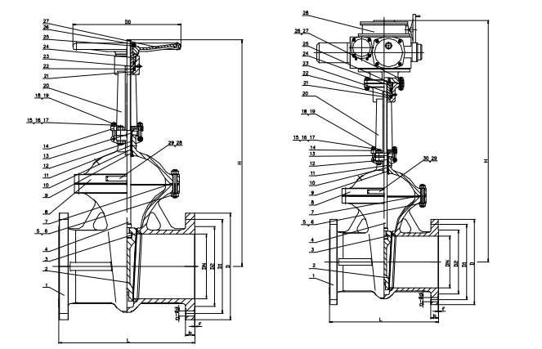
Figure 1 Manual / Electric Flanged Gate Valve


WEIZIDOM GROUP
www.wsdvalves.com
South City, Longhu Town, Xinzheng City,
Zhengzhou City, Henan Province, China

